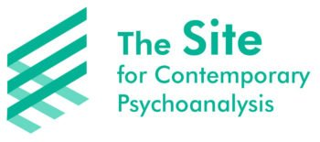
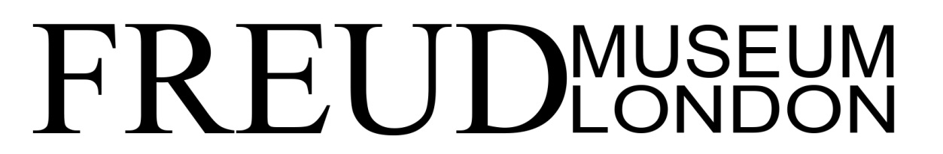
Translation and Psychoanalysis
Saturday 8 June & Sunday 9 June 2019

Speakers’ Biographies

Dorothée Bonnigal-Katz is a psychoanalyst and a translator. She is a member of the SITE for Contemporary Psychoanalysis and one of the editors of Sitegeist: A Journal of Psychoanalysis and Philosophy. She is the founder of the Psychosis Therapy Project. She has translated a number of psychoanalytic works including Dominique Scarfone’s Laplanche: An Introduction (2015) and she translates for the International Journal of Psychoanalysis on a regular basis.

Rubén Gallo is the Walter S. Carpenter Jr. Professor in Language, Literature and Civilization of Spain at Princeton University. He is the author, most recently, of Conversación en Princeton (2017), with Mario Vargas Llosa. Gallo’s other books include Proust’s Latin Americans(2014), an essay about Proust’s Latin American circle of friends in turn-of-the-last century Paris; Freud’s Mexico: Into the Wilds of Psychoanalysis (2010), a cultural history of psychoanalysis and its reception in Mexico; Mexican Modernity: the Avant-Garde and the Technological Revolution (2005), and two books about Mexico City’s visual culture: New Tendencies in Mexican Art (2004) and The Mexico City Reader (2004). He is the recipient of the Gradiva award for the best book on a psychoanalytic theme and of the Modern Language Association’s Katherine Singer Kovacs Prize for the best book on a Latin American topic. He is a member of the board of the Sigmund Freud Museum in Vienna, where he also serves as research director. He is currently at work on “Cuba: A New Era,” a book about the changes in Cuban culture after the diplomatic thaw with the United States.

Berjanet Jazani is a medical doctor and a practising psychoanalyst in London. She is a trustee and an analyst member of the Centre for Freudian Analysis & Research, where she teaches and supervises clinicians and candidates. She is Honorary Secretary of the College of Psychoanalysts-UK. She has given lectures on Lacan in Birkbeck, Middlesex and Bristol universities and gives talks on Psychoanalysis in museums and clinical centres. She has contributed to CFAR Journal “Le Silence de la Mer(e)” JCFAR 2018/2019. Forthcoming publications include: Phoenix: Faces of Desire (Routledge, 2019), Lacan, Forbidden!in Persian (2019), “Smell,” a research project on the concept of Drive in psychoanalysis and olfaction and Never Explained, a collection of essays focusing on the concepts of the Unconscious, desire and jouissance (2020).

Anastasios Gaitanidis is a Senior Lecturer at the University of Roehampton and a member of the Site for Contemporary Psychoanalysis. He is also a Psychoanalytic Psychotherapist in private practice and a Writer. He has published several articles on psychoanalysis and psychotherapy in peer-reviewed journals and he is the Editor of two books: Narcissism – A Critical Reader (2007) and The Male in Analysis – Psychoanalytic and Cultural Perspectives (2011). He is in the process of editing his third book (No) Ordinary Encounters: Psychoanalytic and Aesthetic Perspectives on the Sublime in Everyday Life.

Laurence Kahn is a Training Analyst at the French Psychoanalytic Association (APF) in Paris and she was the President of the APF from 2008 to 2010. She was previously co-editor of the Nouvelle Revue de Psychanalyseand the editor in chief of L’Annuel de l’APF. She has written numerous articles and books, including Psychoanalysis, Apathy and the Postmodern Patient (Routledge, 2018). Her latest book, What Nazism did to Psychoanalysis is currently being translated into English.

Begum Maitra trained in India as a psychiatrist, and after two decades as a child and adolescent psychiatrist in London gave up this discipline altogether to practice exclusively as a psychotherapist. While she was trained as a Jungian Analyst (AJA) her practice includes the diversity of approaches that permeate the mental health field, drawing also on her long practice as an independent expert in family courts, and consultant in related areas. This means that her approach to psychotherapy includes, among other influences, a good measure of those from critical psychiatry, systemic family therapy, and social and cultural anthropology. She writes, supervises, and delivers lectures, workshops, and training when requested. She was co-author with Inga-Britt Krause in 2015 of Culture and Madness (Jessica Kingsley Pub) which includes a film How Culture Matters(Maitra and Livingstone, 2015), and has published numerous papers and chapters on working with culture.

Jonathan Sklar MBBS, FRCPsych is an Independent training and supervising psychoanalyst of the British Psychoanalytic Society. Originally trained in psychiatry at Friern and the Royal Free Hospitals, he later trained in adult psychotherapy at the Tavistock Clinic, London. For many years he was consultant psychotherapist and head of the psychotherapy department at Addenbrooke’s and Fulbourne hospitals in Cambridge. He now works in full-time analytic practice in London. As well as lecturing widely across the world, he has taught psychoanalysis annually in South Africa for over 10 years , termly in Chicago for ten years until 2018 as well as regularly across Eastern Europe. From 2007-2011, he was Vice President of the European Psychoanalytic Federation, with special responsibility for seminars for recently qualified analysts as well as new analytic groups in East Europe. He is presently a board member of the IPA. His books include Landscapes of the Dark – History, Trauma, Psychoanalysis (Karnac, 2011), Balint Matters – Psychosomatics and the Art of Assessment (Karnac, 2017) and Dark Times – Politics History and Mourning (Phoenix, 2018).

Mark Solms is Director of Neuropsychology at the University of Cape Town. He is a member of the British, American and South African Psychoanalytical Associations, and has won many awards, including the Sigourney Prize. He has published over 300 articles and six books. He is editor and translator of the forthcoming Revised Standard Edition of the Complete Psychological Works of Sigmund Freud (24 vols) and the Complete Neuroscientific Works of Sigmund Freud (4 vols). He has spoken at many Freud Museum conferences, including the Poetry Festival in 2016 (‘Word and Image’) and ‘The Unconscious Today’ (2015)

Kristina Valendinova is a psychoanalyst and translator based in London. She is a member of the Cercle Freudien in Paris and a trainee at CFAR.

Barry Watt is a member of The Site for Contemporary Psychoanalysis. He is a Senior Psychotherapist at the Psychosis Therapy Project and a Senior Psychotherapist at St. Mungo’s Community Housing Association in Waltham Forest.

Robert Weiss is a psychoanalyst, supervisor and teacher and a member of the Site for Contemporary Psychoanalysis.

