Translation and Psychoanalysis
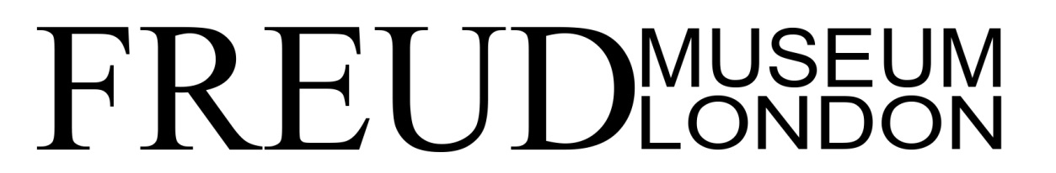
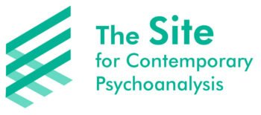
Saturday 8 June & Sunday 9 June 2019

Abstracts - Saturday

Rubén Gallo
Freud’s Spanish: Translinguistic Transexualism
This talk will explore Sigmund Freud’s use of Spanish, a language he learned as a teenager in order to read Cervantes in the original. There has been much theoretical attention devoted to forgotten languages, but this case is different: Freud never forgot his Spanish, since he continued to read scientific literature in this language until the end of his life. But, astonishingly, Spanish was a language he used only with one person: Eduard Silberstein, his childhood friend. I will discuss the relationship between language and love, linguistics and sexuality.

Begum Maitra
Grasping at ‘difference’: Losing and finding culture in translation
All therapeutic exchange might be described as forms of translation, and ‘cultural difference’ could be said to exist in any encounter between two persons, whether by virtue of gender, age or class difference, or early experience of unimaginably different physical and socio-emotional settings. How far do these general truths assist the therapist in multicultural practice? The adult non-western client sufficiently integrated within western cultures may well seek therapy hoping, at least in part, to be translated in ways that ease the conflicts of bicultural lives. But how well are therapists prepared to explore the nature of these conflicts, and how much does it matter whether they translate accurately those desires, inevitably unconscious and inextricably linked with early experience, that lie outside the vocabularies and culturally western imaginations from within which psychotherapy arises. Using material from her practice in psychiatry and psychotherapy the speaker will explore some of the excitements and terrors of such explorations, translations and mis-translations across cultures.

Jonathan Sklar
Psychosomatics, Metaphor and Translation
In this paper contributing to the debate on translation and translatability in psychoanalysis I will be concentrating on ideas around the uses and functions of metaphor in language as a critical form that carries the weight of the unconscious that can transfer, as in transference, understanding and knowledge of that part of the mind.

Mark Solms
Has Freud been falsely scientised? Reflections from the editor of the new Standard Edition – pre-recorded paper
It is widely claimed that the authorised translation of Freud – the Standard Edition of his complete works – tendentiously distorted his writing to make it sound more scientific. For example, the ordinary German word for ‘I’ becomes ‘ego’ in the official translation, ‘occupation’ becomes ‘cathexis and ‘attachment’ becomes ‘anaclisis’. When the editor of the Revised Standard Edition – which appears this year – confronted this question, he was led to surprising conclusions, which he will report in this lecture.

Laurence Kahn
How to Account for the Words of the Morning with the Words of the Night?
Was the mediation of a foreign language necessary to lift repression in the case of Anna O? This paper explores the tension between “the failure of translation” as developed by Jean Laplanche and “this mysterious translation” described by Elias Canetti in The Tongue Set Free, a translation thanks to which, paradoxically, the memories of early childhood, preserved in all their freshness in his mind, were linked to words he did not know at the time. Must the alienness of the unconscious thing therefore be linked to the foreign in order to cross the border of consciousness? Asking the question in this way resonates with Antoine Berman’s dilemma: “How to account for the words of the morning with the words of the night?” According to him, the ethics of translation pertains to the introduction of “strangeness” as opposed to the aims of communication. But, between the attention given to the hidden resonances of Freud’s language, with its etymologies and its resurgences, and the risk of “explaining” his text, perhaps the translation choices are also “political” in the sense that they finally engage a destiny of analytic theory and practice that remains unsuspected at the time when translators translate. I will rely on specific examples to illustrate this problem.

Abstracts - SUNday

Berjanet Jazani
The Art of Translation in Psychoanalysis: from Reciting a Myth to the Poetry of Knots
In light of the conference theme (Translation and Psychoanalysis), I will be exploring the concept of the Real Uncs in the context of “poetry.” I am intending to approach the question of translation in the clinic of the Subject who eventually moves from being a Subject of the Uncs to a Parlêtre.

Robert Weiss
Making Strange: Beckett, Laplanche and Self-Translation
“Anger led me sometimes to slight excesses of language. I could not regret them. It seemed to me that all language was an excess of language. Naturally I confessed them. I was short of sins.” (Molloy)
In this paper I intend, through examining some of the moments of self-translation undertaken by Samuel Beckett, to think about the ways new constructions/translations can be produced in the analytic space. I will focus on some of the ideas of Jean Laplanche—particularly those that engage with the failures of translation that are, after Freud, linked to primal repression—to argue that a process of making strange is needed in order to open up pathways to repressed material. I will examine the extraordinary trilogy of novels Beckett produced between 1955 and 1958, Molloy,
Malone Dies and The Unnamable to think about these questions.

Barry Watt
The Capacity to Cleave Alone: Working therapeutically with the Homeless
This paper explores some key revisions in the fields of metapsychology and clinical technique, necessary to extend psychoanalytic psychotherapy to people experiencing extreme socio-economic deprivation and entrenched homelessness. In so doing, it identifies and critiques a parallel process that is established when supposedly ‘compassionate’ policies towards homelessness are translated into psychosocial clinical responses rooted in Attachment Theory. Arguing that, even as such translations aim to widen the social-inclusion of homeless people, they in fact exacerbate conditions of exclusion through identity-stigmatisation and accommodation-segregation, whereby the homeless are funnelled into paternalistic processes of corrective re-adaptation and normalisation. Drawing on the political thought of Giorgio Agamben and Leonard Feldman, the psychoanalytic work of Winnicott, and the largely neglected work of early Hungarian psychoanalyst Imre Hermann, a revised psychoanalytic anthropology is suggested, with the hope of making clinical work with homeless people more widely available, whilst simultaneously deepening understanding of the socio-political context in which homelessness occurs and is publicly addressed.

Kristina Valendinova
Analysis and Self-Translation: The Question of the Mother Tongue
Contrary to the colloquial understanding of the mother tongue as a first language in which the union between words and things remains largely unperturbed, psychoanalysis helps us think differently about the contingencies and commitments of our immersion in the mother tongue, positing that any language that is to be inhabited must already be permeated with lack.

