Job Description
JOB TITLE: Membership and Development Assistant
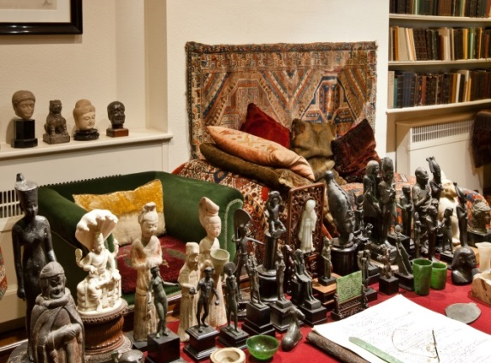
REPORTS TO: Development and Marketing Manager
Part-time: 3 days a week, 9.30am – 5.30pm plus some evenings and weekends for events
Salary: £14,100pa (pro-rata full time £23,500 pa)
Based at Freud Museum London, 20 Maresfield Gardens,
London NW3 5SX

Application to include CV and covering letter by email to Monica Law, Development and Marketing Manager, monica@freud.org.uk.
Closing date for applications: Noon, Thursday 13 December 2018
Interviews will be held on Wednesday 19 December 2018
Job to commence as soon as possible

Overview
The Freud Museum London was the final home of Sigmund Freud, the founder of psychoanalysis, who came here in 1938 after fleeing Nazi-occupied Vienna. Here visitors can see Freud’s study and the original, now iconic couch on which Freud’s patients told him their memories. It also houses the personal possessions of Freud’s daughter Anna, herself a prominent child psychoanalyst.

The Museum is an independent charity, with no regular public funding. Most of the Museum’s income is raised through admissions, events and commercial activities such as private hire and shop sales. The Museum is planning a major capital programme to support ambitious development aims that will deliver better services and facilities for visitors, events and education needs. Phase one of the development plan is in progress and we are increasing the capacity of fundraising team to raise funds to support the re-development of the Museum.

The role
Working closely with the Development and Marketing Manager and Director, the role and the post holder will facilitate the membership scheme of the Museum and support fundraising activities.

Responsibilities

- To provide a high level of service to Members, Donors and Patrons and ensure all supporters are supported in a way which will make them feel valued, encouraging their long-term support

- To take ownership of and maintain the effective running of the membership scheme of the Museum including:
  - Processing subscriptions, issuing membership cards, sending renewal reminders
  - Sending timely and empathetic communications and responding to queries
  - Updating the Museum CRM appropriately
  - Keeping abreast of payment subscriptions

- To work with the Development and Marketing Manager to develop and implement the annual fundraising plan and participate in the delivery of aims and targets including:

  - Assisting with researching and implementing new systems to support fundraising (e.g. contactless giving)
  - Assisting with promoting fundraising initiatives and appeals via social media, website, online articles
  - Undertaking desk-based research to assist with identifying potential donors and supporters
- To provide administrative support for the Patrons scheme, and Donors using the Museum CRM system (Donorfy), including:
  - Effective and accurate data maintenance, creating distribution lists for communications (email/post)
  - Assisting with the preparation and distribution of appeals or other targeted communications (e.g. Festive Season), by mail/email/social media
  - Sending reminders and managing bookings for Patrons only/Donor events, and assisting with delivering these
  - Processing donations, writing and sending timely thank you and other communications
  - Maintaining record of crediting requirements for Donors and Patrons to ensure they are acknowledged correctly
  - Assisting in the identifying and tracking of new and existing prospects on the CRM system
  - Supporting the Museum Development Group, for example, by preparing prospect research papers or lists
  - Maintaining up-to-date lists for the Museum monthly e-news, PV invitations and other Museum events
- To assist with the organisation and delivery of fundraising events, including:
  - Creating invitation lists for distribution via Mailchimp
  - Creating events and booking systems on Event Brite
  - Coordinating invitations, responding to RSVPs and maintaining this information accurately on the CRM system
  - Setting-up events, distributing briefing notes and schedules ahead of time
- To support the development of a Legacy programme
- To liaise with other colleagues in the Museum to maintain accurate records of supporters and on functionality developments of Donorfy CRM as required.

PERSONAL SPECIFICATION: Development Assistant

ESSENTIAL | DESIRABLE
TRAINING, EXPERIENCE AND QUALIFICATIONS
Demonstrable previous experience in fundraising  Experience of using fundraising CRM systems and databases  Demonstrable office and administration experience  Experience of communicating with, and managing successful relationships with external stakeholders | Experience of applying for grants to Trusts and Foundations  Marketing experience, online and social media  Experience of working in the arts or cultural heritage sector  Experience of providing events support  Interest in Sigmund Freud, Anna Freud and psychoanalysis
KNOWLEDGE AND SKILLS
Able to communicate effectively and appropriately with individuals at different levels  Excellent organisational skills  Able to manage own time and work to a deadline  Excellent attention to detail and record keeping  Professionalism in completing tasks  Fully computer literate | Knowledge of GDPR best practice  Knowledge of Gift Aid  Knowledge of UK trusts, foundations and corporate giving in general  Ability to produce concise and creative bids  Confidence in writing online copy and engaging supporter communications
INTERPERSONAL SKILLS
Ability to work under own initiative and also as part of a wider team
Relationship building and influencing skills
Excellent written and verbal communication and skills
An interest in heritage and history
Willingness to work outside normal office hours when required

