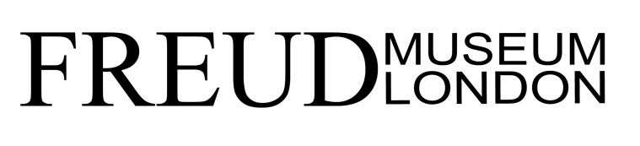
Digital Manager: Job Description

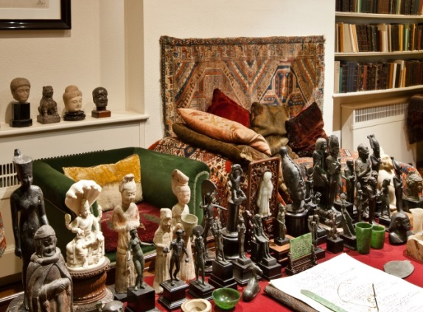
Reports to: Director
Part-time: 2.5 days a week, hours can be worked flexibly
Salary: £12,500pa (pro-rata full time £25,000 pa)
Based at Freud Museum London, 20 Maresfield Gardens,
London NW3 5SX

Application to include CV and covering letter outlining your suitability for the job and why you are applying,
by email to Verity Bridge, Planning Assistant, verity@freud.org.uk
Closing date for applications Monday 22 July at 9am
Interviews will be held in the week beginning 5 August 2019
Job to commence as soon as possible

Overview

The Freud Museum London was the final home of Sigmund Freud, the founder of psychoanalysis, who came here in 1938 after fleeing Nazi-occupied Vienna. Here visitors can see Freud’s study and the original, now iconic couch on which Freud’s patients told him their memories. It also houses the personal possessions of Freud’s daughter Anna, herself a prominent child psychoanalyst.

The museum is an independent charity, with no regular public funding. Most of the museum’s income is raised through admissions, events and commercial activities such as private hire and shop sales. The Museum is planning a major capital programme to support ambitious development aims that will deliver better services and facilities for visitors, events and education needs. Phase one of the development plan is in progress.

A digital strategy was agreed in 2017, focusing on engagement, financial sustainability, collections and digital culture. The museum’s website was redeveloped in 2018.

The role

The Digital Manager will be responsible for implementing and updating the museum’s digital strategy, and ensuring that the museum connects with the broadest range of digital audiences and provides an excellent online experience. The post holder will oversee the creation and delivery of effective digital content that drives reach, revenue, reputation and engagement.

The Digital Manager will work closely with colleagues across the museum, including curatorial, events, education, marketing and fundraising to create a ‘joined up’ approach to digital activities across all channels and departments.

The role will suit a digital all- rounder with an interest in museums, someone who has the ability to quickly become familiar with a range of platforms and be able to solve digital problems.

Responsibilities

Key duties
- To take chief responsibility for FML’s website and related digital products
- To take a strategic approach to increasing reach through SEO and quality referrals
- To ensure that FML’s digital content optimises opportunities to drive reach , engagement and revenue across all digital channels
- To manage the Museum’s social media channels
- To act as a liaison with external digital agencies and consultants.
- To lead in troubleshooting and resolving digital issues as they come up.
- To use analytics and other tools to evaluate the website and digital output, and to build findings into future projects

Technical
- To offer technical oversight and management of key digital products and systems (including Wordpress, Eventbrite, Stripe, GoCardless, Adlib API, Donorfy, Shopify, Podbean, Mailchimp, Google Analytics and Google Tag Manager).
- To offer IT troubleshooting and emergency support for all staff.

Digital content
- To copy-edit all blog posts, exhibition listings, event listings and e-news mailouts.
- To develop and write new digital content in a range of formats, including written, video, audio and interactive.
- To work with colleagues and external content writers (such as curators) to agree, create and manage the delivery of new content and targeted campaigns, and monitor effectiveness in driving actions, e.g. increasing website traffic, sales, donations or engagement.
- To uphold and promote best practices for web copy in SEO and web accessibility, and in accordance with the Museum’s style guide
- To maintain and update FM’s podcast feed and YouTube channel.
- To proactively seek out ways to support the museum’s activities by commissioning or authoring related content and posting to social media.

Strategy and direction
- To review and update the museum’s digital strategy.
- To explore possible development work on web platforms, including alternative event ticketing solutions, new podcasting arrangements and collections-based storytelling.
- To work on digital plans for the museum’s proposed redevelopment
- To promote digital literacy across the organisation, and joined up digital thinking.
- To uphold best practices for data protection in accordance with GDPR.
- To produce regular reports for the Board of Trustees on the museum’s digital impact and related matters.

PERSONAL SPECIFICATION: Digital Manager

ESSENTIAL | DESIRABLE
TRAINING, EXPERIENCE AND QUALIFICATIONS
Background in digital communications, with demonstrable previous experience of delivering digital strategy and managing the development and production of engaging and impactful digital content  Experience of using data insights to monitor performance and inform content decisions  Experience of writing, editing and publishing for web, including delivering audience focussed and search optimized material  Experience of using Google Analytics  Good technical knowledge of IT and software systems, enough to provide first level back up  Good research and analytical skills | Educated to degree level or equivalent  Experience of working in the arts or cultural heritage sector  Interest in Sigmund Freud, Anna Freud and psychoanalysis  An interest in heritage and history
KNOWLEDGE AND SKILLS
Excellent writing skills with a keen eye for an engaging story, excellent grammar and a close attention to detail  A demonstrable interest in the latest developments in digital media and their possible application in a museum context  Able to communicate effectively and appropriately with individuals at different levels  Excellent planning and organisational skills  Able to manage own time and work to a deadline | Knowledge of accessibility issues in relation to digital provision
INTERPERSONAL SKILLS
Ability, knowledge and personal abilities to act as a specialist advisor on digital content

Ability to work under own initiative and also as part of a wider team
Excellent written and verbal communication skills
Willingness to work outside normal office hours when required

June 2019

